**Tripler Army Medical Center**

**Interdisciplinary Pain Management Clinic**

**Initial Pain Assessment Tool**

|  |  |
| --- | --- |
| **Name:** | **Date of Birth:** |
| **Primary/Mobile Phone:** | **Occupation/MOS:** |
| **Marital Status:** | **Children Age/Gender:** |
| **Number of Years in Military Service:** | **How Many More Years in Military Service:** |

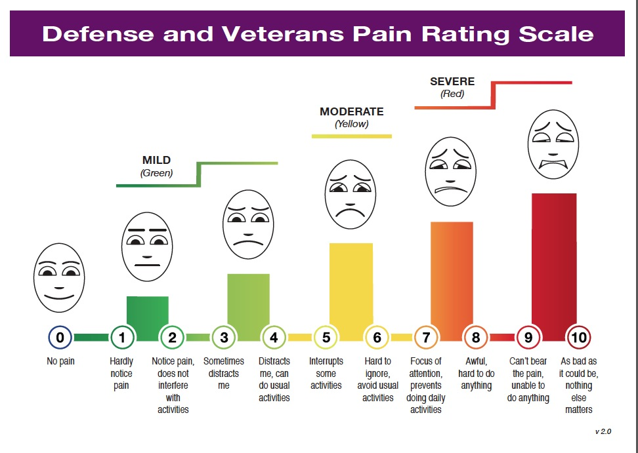

**Please rate your pain using DoD/VA functional pain ratings scale above (circle the appropriate number):**

|  |  |  |  |  |  |  |  |  |  |  |  |  |
| --- | --- | --- | --- | --- | --- | --- | --- | --- | --- | --- | --- | --- |
| **Present Pain Level?** | **0** | **1** | **2** | **3** | | **4** | **5** | **6** | **7** | **8** | **9** | **10** |
| **In the past 24 hours how much has pain interfered with your ACTIVITY?** | **0** | **1** | **2** | **3** | | **4** | **5** | **6** | **7** | **8** | **9** | **10** |
| **In the past 24 hours how much has pain interfered with your SLEEP?** | **0** | **1** | **2** | **3** | | **4** | **5** | **6** | **7** | **8** | **9** | **10** |
| **In the past 24 hours how much has pain affected your MOOD?** | **0** | **1** | **2** | **3** | | **4** | **5** | **6** | **7** | **8** | **9** | **10** |
| **In the past 24 hours how much has pain affected your STRESS?** | **0** | **1** | **2** | **3** | | **4** | **5** | **6** | **7** | **8** | **9** | **10** |
| **In the past month what is your AVERAGE pain level?** | **0** | **1** | **2** | **3** | | **4** | **5** | **6** | **7** | **8** | **9** | **10** |
| **In the past month what was your HIGHEST pain level?** | **0** | **1** | **2** | **3** | | **4** | **5** | **6** | **7** | **8** | **9** | **10** |
| **In the past month what was your LOWEST pain level?** | **0** | **1** | **2** | **3** | | **4** | **5** | **6** | **7** | **8** | **9** | **10** |
| **Do you use any type of tobacco or nicotine?** | | | | | **□ Yes** | | | | | **□No** | | |
| **Type and amount:** | | | | | | | | | | | | |
| **Do you drink alcohol?** | | | | | **□ Yes** | | | | | **□No** | | |
| **Type, frequency, and amount:** | | | | | | | | | | | | |
| **Do you have any allergies to foods or medications?** | | | | | **□ Yes** | | | | | **□No** | | |
| **Are you having any medication side effects?** | | | | | **□ Yes** | | | | | **□No** | | |
| **Is this visit related to deployment?** | | | | | **□ Yes** | | | | | **□No** | | |
| **Do you have any barriers to learning?** | | | | | **□ Yes** | | | | | **□No** | | |

***Please mark the locations of your pain on the diagram:***

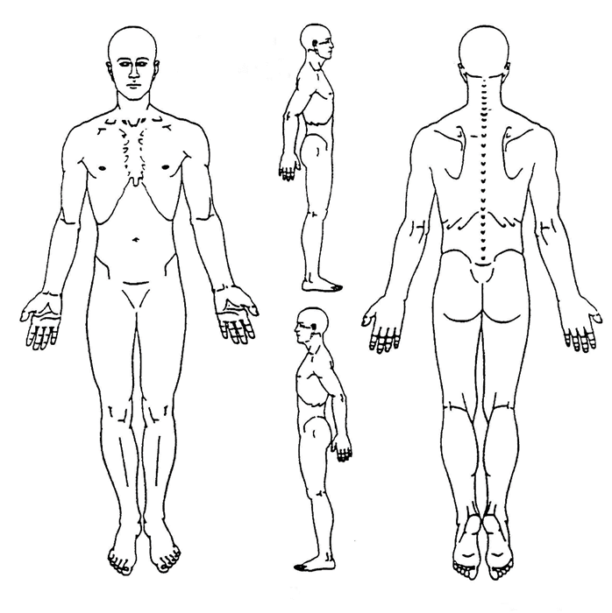

|  |  |  |  |  |  |  |  |  |  |  |  |  |  |  |  |  |  |
| --- | --- | --- | --- | --- | --- | --- | --- | --- | --- | --- | --- | --- | --- | --- | --- | --- | --- |
| **Please Describe your pain:** | **□ Sharp** | **□ Dull** | **□ Shooting** | **□ Radiating** | | | | | | | | **□ Stinging** | | | | | |
| **□ Stabbing** | **□ Burning** | **□ Throbbing** | **□ Numbness** | | | | | | | | **□ Aching** | | | | | |
| **When did your pain start?** | | | | | | | | | | | | | | | | | |
| **Did your pain start with a particular injury or physical training event?** | | | | | | | | | | **□ Yes** | | | | | **□No** | | |
| **Are you currently on permanent profile?** | | | | | | | | | | **□ Yes** | | | | | **□No** | | |
| **Are you currently on temporary profile?** | | | | | | | | | | **□ Yes** | | | | | **□No** | | |
| **Are you currently in MEB or WTU or on disability/con leave/alternate duty?** | | | | | | | | | | **□ Yes** | | | | | **□No** | | |
| **Are you taking blood thinners? (Coumadin/Warfarin, Ticlid/Ticiopidine, Ginko, Aspirin, Heparin, Lovenox/Enoxaparin, Apixaban/Eliquis, Betrixaba/Bevyxxa)** | | | | | | | | | | **□ Yes** | | | | | **□No** | | |
| **Are you getting at least 6 hours of good sleep? (restful and less than 2 awakenings)** | | | | | | | | | | **□ Yes** | | | | | **□No** | | |
| **Are you on the Anti-Inflammatory diet or other specific diet?** | | | | | | | | | | **□ Yes** | | | | | **□No** | | |
| **Please list current career goal(s):** | | | | | | | | | | | | | | | | | |
| **Please list current exercise regimen:** | | | | | | | | | | | | | | | | | |
| **Please list additional sports/recreational/fun activities:** | | | | | | | | | | | | | | | | | |
| **How willing to make major changes in your diet are you? (0=not at all)** | | | | | **0** | **1** | **2** | **3** | **4** | | **5** | | **6** | **7** | **8** | **9** | **10** |
| **How willing to make major changes in your exercise regimen are you?** | | | | | **0** | **1** | **2** | **3** | **4** | | **5** | | **6** | **7** | **8** | **9** | **10** |
| **How willing to make major changes in your life are you?** | | | | | **0** | **1** | **2** | **3** | **4** | | **5** | | **6** | **7** | **8** | **9** | **10** |

**Patient History (Please circle all that personally apply):**

|  |  |  |
| --- | --- | --- |
| **Current use if nicotine** | **Currently drink more than 6 alcoholic drinks per week** | **Cancer** |
| **Current use of steroids** | **Heart attack/MI** | **Heart failure** |
| **Cardiac arrhythmia** | **Hypertension** | **Heart murmur (significant)** |
| **Sleep Apnea** | **TB/Tuberculosis** | **Asthma** |
| **Chronic or Recurrent Bronchitis** | **COPD/Emphysema** | **Muscle Disease** |
| **Broken bones** | **Osteoporosis** | **Fibromyalgia** |
| **Inflammatory Arthritis** | **Myopathy** | **Adrenal Disease** |
| **Diabetes** | **Thyroid disease** | **Pituitary Disease** |
| **Ulcer** | **Hiatal Hernia** | **Inflammatory Bowel Disease** |
| **Pancreatitis** | **Hepatitis** | **Liver Disease** |
| **Kidney Stones** | **Kidney Disease** | **Recent Infection** |
| **Anemia** | **Sickle Cell Disease** | **Immunosuppression** |
| **HIV/AIDS** | **Recent Trauma and/or Fall** | **PTSD** |
| **Schizophrenia/Bipolar Disorder* (entire row 2M/2F)** | **Obsessive Compulsive Disorder* (entire row 2M/2F)** | **ADHD/ADD\***  **(entire row 2M/2F)** |
| **Use of Illegal Drugs \***  **(4M/4F)** | **Alcohol Abuse/Alcoholism\***  **(3M/3F)** | **Abuse of Prescription Drugs* (5M/5F)** |
| **Depression\***  **(1M/1F)** | **Child Sexual Abuse Survivor* (0M/3F)** | **Age 16-45 years old\***  **(1M/1F)** |

**Review of Systems (Please circle all that apply):**

|  |  |  |
| --- | --- | --- |
| **Fever/Chills** | **Cough** | **Shortness of Breath** |
| **New loss of Taste or Smell** | **Unusual/Severe Headaches** | **Generalized Body Aches/Pain** |
| **Unusual/Severe Fatigue** | **Unexplained Weight Loss** | **Dizziness** |
| **Altered taste** | **Runny Nose** | **Sore Throat** |
| **Blurry Vision** | **Hearing Loss** | **Wheezing** |
| **Coughing Blood** | **Chest Pain** | **Palpitations** |
| **Nausea/Vomiting/Diarrhea** | **Persistent or Severe Diarrhea** | **Blood in Stool** |
| **Loss of Bowel Control** | **Loss of Bladder Control** | **Blood in Urine** |
| **Sexual Problems** | **Prolonged Bleeding** | **Easy Bruising** |
| **Memory Loss** | **Numbness of Arms or Hands** | **Numbness of Legs or Feet** |
| **Seizures/Tremors** | **Depressed Mood** | **Insomnia/Difficulty with sleep** |
| **Loss of Sensation /Tingling to the Genital Region** | **Loss of Interest/Pleasure in Doing Things** | **Thoughts of Self-harm/Suicide** |

**Please list any procedures or surgeries you have had:**

|  |  |
| --- | --- |
| **Doctor/Clinic/Hospital** | **Procedure/Reason/Diagnosis** |
|  |  |
|  |  |
|  |  |
|  |  |
|  |  |

**Please circle all that apply to family members:**

|  |  |  |
| --- | --- | --- |
| **Rheumatoid Arthritis** | **Lupus/SLE** | **Ankylosing Spondylitis** |
| **Scleroderma/CREST** | **Psoriatic/IBD/Reiter’s Arthritis** | **Heart Attack/MI** |
| **Stroke** | **Diabetes** | **Cancer** |
| **Prescription Drug Abuse* (4M/4F)** | **Alcoholism/Alcohol Abuse\***  **(3M/1F)** | **Illegal Drug Use\***  **(3M/2F)** |

**Please indicate all treatments you have tried to treat your pain:**

|  |  |  |  |
| --- | --- | --- | --- |
| **TREATMENT** | **Tried it?** | **Currently use it?** | **Does it help?** |
| **Physical Therapy with Home Exercises** | **□ Yes** | **□ Yes** | **□ Yes** |
| **Physical Therapy with Dry Needling** | **□ Yes** | **□ Yes** | **□ Yes** |
| **Physical Therapy with Ultrasound** | **□ Yes** | **□ Yes** | **□ Yes** |
| **Physical Therapy Directed Home Exercises** | **□ Yes** | **□ Yes** | **□ Yes** |
| **Chiropractic Care** | **□ Yes** | **□ Yes** | **□ Yes** |
| **Professional or Medical Massage** | **□ Yes** | **□ Yes** | **□ Yes** |
| **Acupuncture** | **□ Yes** | **□ Yes** | **□ Yes** |
| **Rolling/Ball Rolling/Self Massage** | **□ Yes** | **□ Yes** | **□ Yes** |
| **Cupping/Gua Sha** | **□ Yes** | **□ Yes** | **□ Yes** |
| **Traction or Inversion Table** | **□ Yes** | **□ Yes** | **□ Yes** |
| **Stretching** | **□ Yes** | **□ Yes** | **□ Yes** |
| **TENS Unit** | **□ Yes** | **□ Yes** | **□ Yes** |
| **Biofeedback/Self-Regulation** | **□ Yes** | **□ Yes** | **□ Yes** |
| **Psychology/Counseling/CBT for Pain** | **□ Yes** | **□ Yes** | **□ Yes** |

**Please list all medications, herbs, and supplements that you are currently taking (include ALL medications, not just pain medication):**

|  |  |  |  |  |  |  |
| --- | --- | --- | --- | --- | --- | --- |
| **Medication** | **Dose** | **# Taken** | **How often** | **Start Date** | **Prescribed by** | **Does it Help?** |
|  |  |  |  |  |  | **□ Yes □No** |
|  |  |  |  |  |  | **□ Yes □No** |
|  |  |  |  |  |  | **□ Yes □No** |
|  |  |  |  |  |  | **□ Yes □No** |
|  |  |  |  |  |  | **□ Yes □No** |
|  |  |  |  |  |  | **□ Yes □No** |
|  |  |  |  |  |  | **□ Yes □No** |

**Please list all medications, herbs, and supplements that you have taken in the past for pain:**

|  |  |  |  |
| --- | --- | --- | --- |
| **Name of Medication** | **Did it Help?** | **Name of Medication** | **Did it Help?** |
|  | **□ Yes □No** |  | **□ Yes □No** |
|  | **□ Yes □No** |  | **□ Yes □No** |
|  | **□ Yes □No** |  | **□ Yes □No** |
|  | **□ Yes □No** |  | **□ Yes □No** |

|  |  |  |
| --- | --- | --- |
| **HEIGHT:** | **WEIGHT:** | **PULSE:** |
| **BP:** | **RESPRIATIONS:** | **ORT SCORE*:** |